How to avoid the error “Disk space is below threshold of 1.00 GiB. “
When we login into Jenkins without creating any jobs, getting error in the build executor status.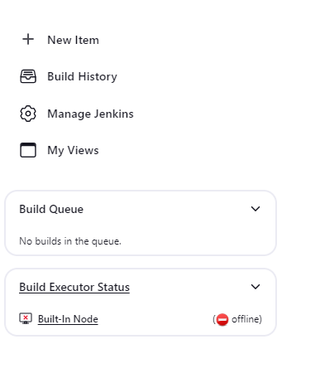
Go to the status in the Manage Jenkins, it displays the error message i.e disk space is below the threshold.
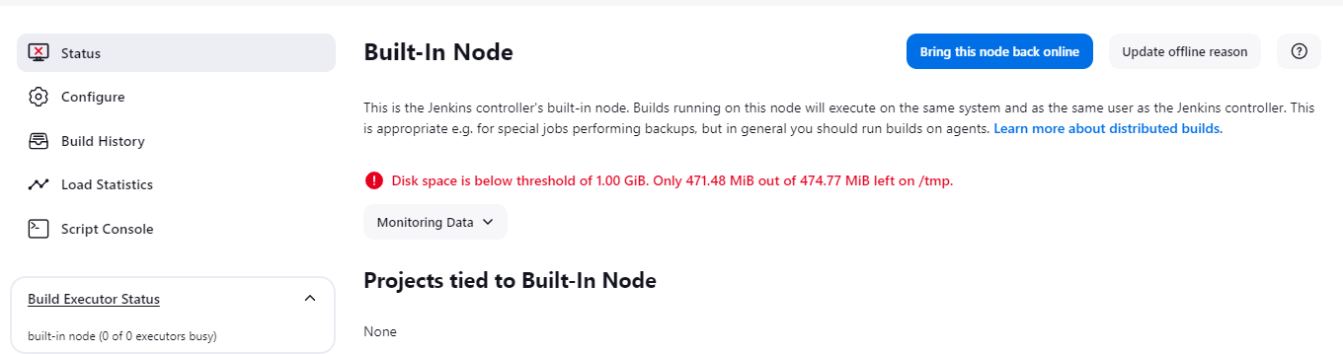

To check disk space of usage use command df-h
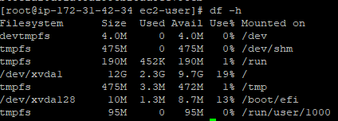

Here only 475Mb free space on /tmp partition.It is almost nothind.jenkins has a default 1GB for for disk space.so increased disk space to 1Gb

When 1gb diskspace is increased by using the above command,the /temp partition size is increased to 1gb.
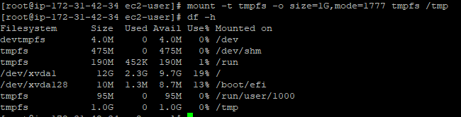

After increasing the size to 1Gb ,the error remains same. 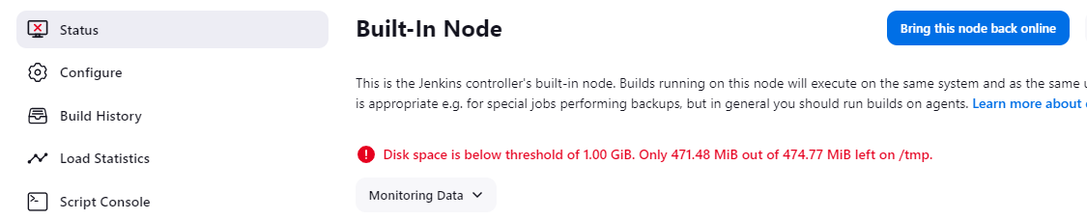

Because of type of EC2 instance i.e t2.micro when I run Jenkins.Created the instance with more space and loading 2Gb.so we increase the diskspace to 3Gb

Disk space is increased to 3Gb is shown by below command
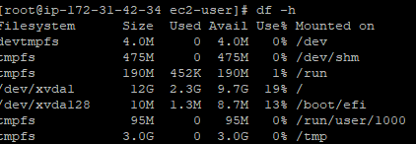

Now the error is solved.
